**Bahria University, Lahore Campus**

Department of Computer Sciences

Lab Journal 08

**(Fall 2023)**

|  |  |  |
| --- | --- | --- |
| Course: | **Digital Communication Network Lab** | Date: 23-11-2023 |
| Course Code: | CSL-320 | Max Marks: 20 |
| Faculty’s Name: | Dawood Akram | Lab Engineer: Muhammad Umar Nasir |

Name: \_affan ahmad\_\_\_\_\_\_\_\_\_\_\_\_\_\_\_\_\_\_ Enroll No: \_03-134221-003\_\_\_\_\_\_\_\_\_\_

**Objective(s):**

In this lab, students will learn how to implement routing protocols using packet tracer.

**Tool(s) used:**

CISCO packet tracer

**EIGRP Overview:**

EIGRP (Enhanced Interior Gateway Routing Protocol) is an advanced distance vector routing protocol. This protocol is an evolution of an earlier Cisco protocol called IGRP, which is now considered obsolete. EIGRP supports classless routing and VLSM, route summarization, incremental updates, and load balancing and many other useful features. It is a Cisco proprietary protocol, so all routers in a network that is running EIGRP must be Cisco routers.

Each EIGRP router stores routing and topology information in three tables:

•    Neighbor table – stores information about EIGRP neighbors   
•    Topology table – stores routing information learned from neighboring routers  
•    Routing table –  stores the best routes

## Application of EIGRP on Packet Tracer

Apply Enhanced Interior Gate Way Routing Protocol (EIGRP) on packet tracer.  Here are the basic set of commands that we can apply on router CLI mode in order to apply EIGRP on router.   
[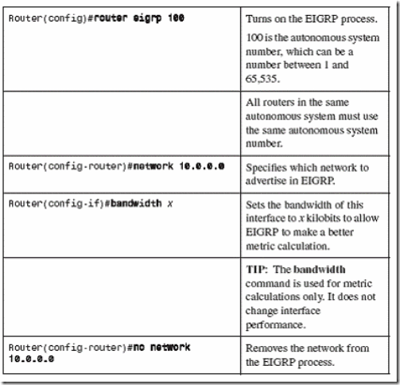](http://lh4.ggpht.com/-l310b24gDHQ/UIKGkeHoHMI/AAAAAAAAAbM/Fl0h3KcIFpQ/s1600-h/clip_image002%255B4%255D.gif)

Also, look at some additional commands.   
[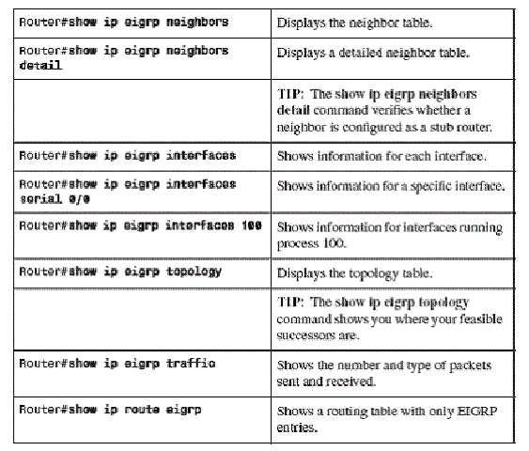](http://lh3.ggpht.com/-SNHiyQ9DU4A/UIKGqvbKHPI/AAAAAAAAAbc/ugDO5Op3O2A/s1600-h/clip_image002%255B7%255D%255B3%255D.gif)

**Apply EIGRP on the following topology:**  
  
[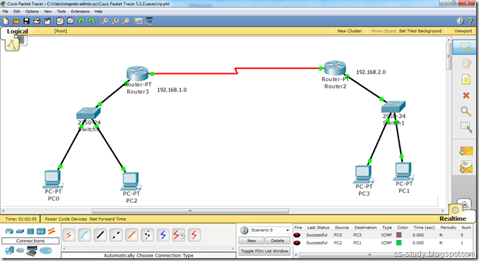](http://lh4.ggpht.com/-5Lbwx6cPhHs/UIKGwhRXErI/AAAAAAAAAcM/0CMu-rbzy4w/s1600-h/eigrp%2520diagram%255B10%255D.png)

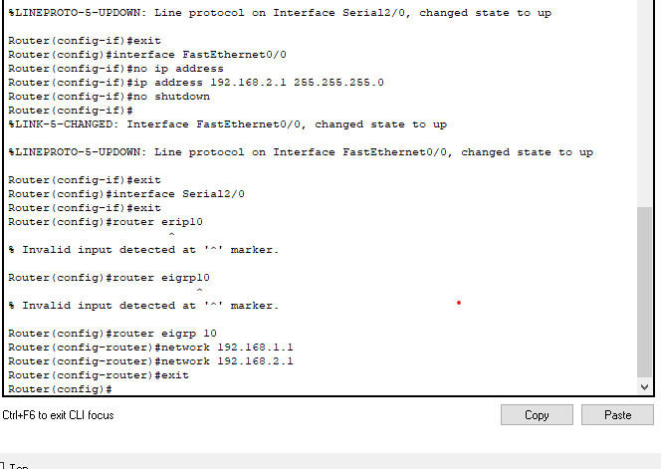

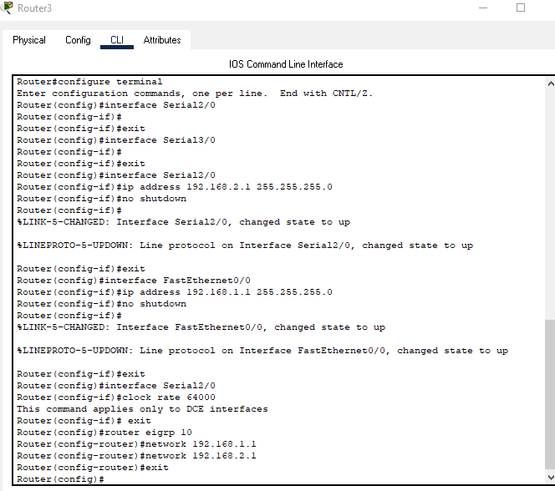

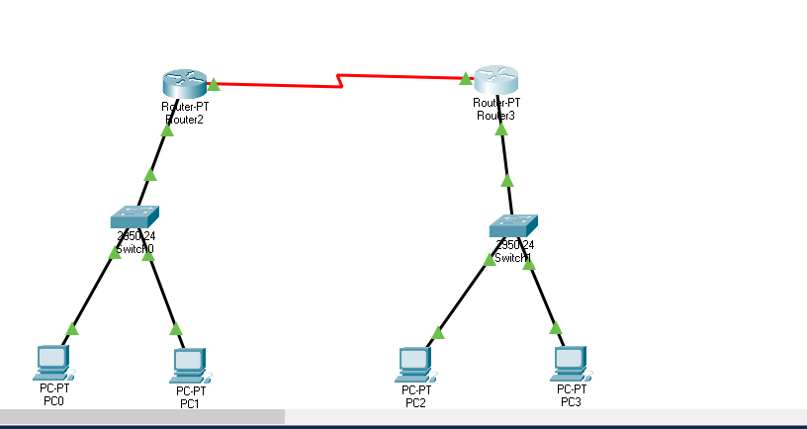

**Step 1:** Applying IP addresses like in this [topology](http://cs-study.blogspot.com/2012/10/communication-between-pcs-in-packet.html" \t "_blank), we will apply following commands. 

Router(config)#router eigrp 10  
Router(config-router)#network 192.168.1.0  
Router(config-router)#network 192.168.2.0  
Router(config-router)#exit   
  
**Step 2:** Apply the above set of commands on both routers like this.   
  
[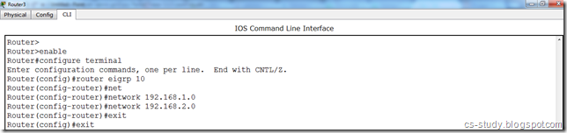](http://lh3.ggpht.com/-AMgpYBr64fA/UIKG2Vwf8xI/AAAAAAAAAcU/U5hs4m8XwhA/s1600-h/eigrp%25201%255B20%255D.png)  
  
And eigrp protocol has been applied on this topology. Notice the following command.

Router eigrp 10   
This number ‘10' is the process ID.